To: Jim Beene Date: July 12, 2004
From: Jim Ball
Subject: A Recommendation for Increasing RIB Yields at HRIBF
cc: Alan Tatum, Sig Mosko

INTRODUCTION:
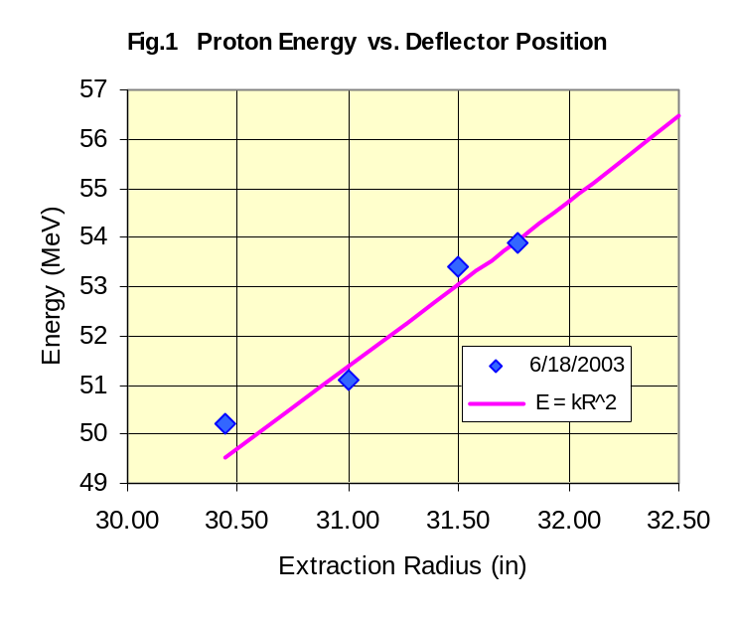
In August of 2003, the extraction radius for the ORIC proton beam was successfully increased from 28.6 to 31.7 inches. The only results for which we made a careful estimate of the beam energy using BSM_1_1, are shown in Figure 1. Even these are subject to large errors due to the insensitivity of this bending magnet as an energy measuring device. To the extent that these measurement are a good approximation, this would suggest that the proton beam energy was raised from about 43 MeV (at the old deflector entrance position of 28.6 inches) to 54 MeV, or an energy increase of about 25%.
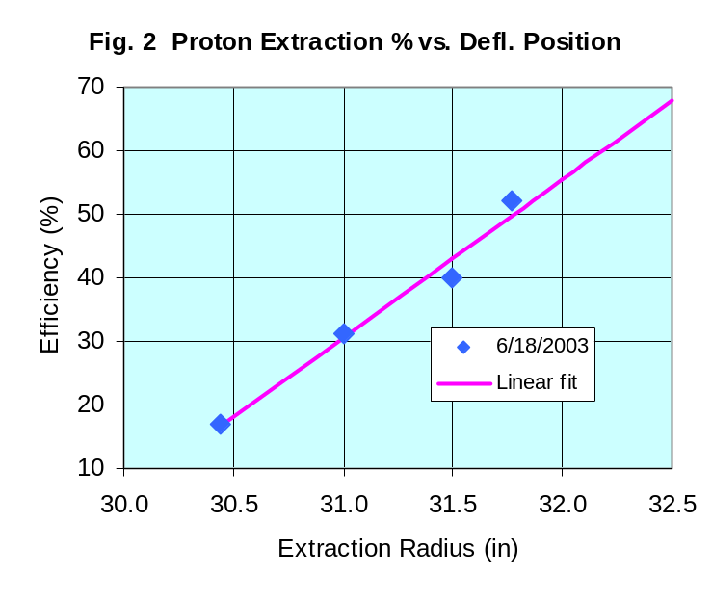
Shown in Figure 2 are the beam extraction efficiencies measured for these same energies. After passing through the interference minimum, which occurs at 30 to 30½ inches, the rise in efficiency seems approximately linear with extraction radius.
The purpose of this note is to examine two possibilities for further increasing the proton beam performance capabilities of ORIC, to look at the benefit to effort ratio involved in these changes, and to suggest an upgrade path that could lead to significant improvements in RIB production with rather modest cost and effort involved.

UPGRADE POSSIBILITIES:
There are two principal approaches that seem to be worth exploring. One is to increase the travel of the deflector entrance so that the beam can be extracted at a larger radius. The other is to increase the rf frequency of the resonator.
1. Increase the Deflector Entrance Radius
This approach would require modifying the deflector entrance hanger to accommodate another ½ inch of travel. Depending on the actual position of the pin in the hanger slide when the deflector is now at full travel, this could be as simple as repositioning one mounting hole in the present hanger bar. More likely, a new hanger would need to be fabricated, but this is a relatively small and inexpensive part. The major expense would be in the effort to remove the deflector to work on the hanger, and then to reinstall and carefully recalibrate the deflector entrance position.
A major uncertainty in this approach is just how far the performance shown in Figures 1 and 2 can be extrapolated in radius. According to the field profiles taken from the Cleary program, the field profile “roles over” at about 30.7 inches. Thus we are already extracting well beyond this role-over, and very likely at or just beyond the ν_{r}=1 resonance. I should note that the predicted field profiles agree very well with the original set of field measurement data and thus I suspect are giving a good representation of the present field properties.
At best I suspect we might be able to push extraction out to 32 or 32¼ inches. According to Figure 1, this would gain us about another 1 MeV in proton energy. We might also be able to gain another 10% or so in extraction efficiency, but I suspect there are easier ways to achieve this.
My personal opinion is that this is not a very fruitful course to pursue in terms of the rather small potential gains when measured against the effort involved.
2. Increase the Frequency Range of the RF System
The present upper frequency limit of the resonator is a result of increasing the Dee-to-liner capacity when the new Dee was built for coupled operation. This change lowered the operating frequency down to a point where we obtained a good overlap between 1st and 3rd harmonic operation. For the present mission of ORIC, this is no longer required. The increase in capacitance was achieved by putting a “bow” in the sides of the Dee so that the Dee-to-liner spacing was reduced.
Figure 3 shows data taken from a number of old runs that illustrate the dependence of the proton energy on the rf frequency. With the original Dee, ORIC was operated routinely at frequencies up to 22½ MHz. The lines in the figure show the expected dependence of proton energy with rf frequency as a function of the extraction radius. The line for 28.6 inches represents the most commonly used extraction radius setting for protons prior to the improvements discussed above. Also shown are lines for 30 inches and the maximum extraction radius achieved in the above studies of 31.8 inches. The values of proton energy along the 19 MHz line are the same as those plotted in Figure 1. Obviously, if the frequency can be increased to the order of 21 MHz, the accompanying increase in energy could be another 25%.
There are at least two ways to reduce the Dee-to-liner capacity. The most obvious is to mechanically “squeeze” the Dee and reduce or remove the bowing. The second is to back the Dee slightly out of the vaccum chamber, which increases the Dee-to-dummy-Dee distance and also the average Dee-to-liner spacing.
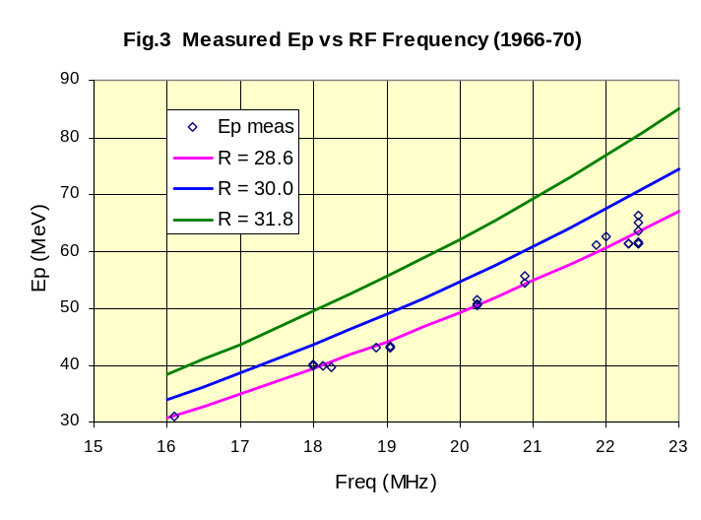
Backing the Dee out of the vacuum chamber could be accomplished by fabricating a spacer ring (something like ¼ of an inch thick) the diameter of the resonator tank. The only upside I see to this approach is that it would allow the space needed for the insertion of a future axial injection source. Other than that, this seems like a very complicated approach and one that has unknown effects on the beam dynamics. Besides, I think there are better ways to accommodate the space needed for the axial source.
The approach of reforming the Dee to remove the bowing seems at first glance to be rather simple. With the Dee backed out of the vacuum chamber, a mechanical squeeze would need to be imposed on the Dee sides. This could be accomplished by either using a large “C” clamp type device, or by drilling a very small hole through the Dee sides in the region of maximum bowing and using a wire passed through the Dee at this point to support the squeezing force. The “C” clamp approach seems to me to have more flexibility and is less invasive. There may well be other approaches that are even better.
A major concern is how amenable the Dee is to such a treatment. The biggest question here may be how malleable the copper is in its present condition. I.e., what is the state of Dee embrittlement due to the time spent in its operating environment? This is something that would require some careful study – repairing a cracked Dee is something to be avoided! It is also not a given that the purported increase in energy is a sure thing. Although we used to operate routinely at 63 MeV, we no longer have the use of trim coils 9 and 10. This may give some challenges in being able to shape the field correctly. However, the iron pole tips were designed to favor high energy protons, so that may be a saving feature here. Still, we will be going into uncharted territory.
Given a satisfactory answer to the condition of the copper, reforming the Dee to provide higher rf frequencies would seem to offer a strong possibility of considerable gain in performance for a fairly modest expenditure of resources.

RECOMMENDATION:
The possibility of increasing ORIC proton energy by increasing the rf frequency should be included in any future study of upgrading ORIC performance. This offers the good possibility of a significant energy increase at a small cost, with a concomitant increase in RIB production.
APPENDIX:
A more complete plot of the proton energy projection along the 19.0 MHz line of Figure 3 is given in the figure below. Here, the old data point from protons extracted at an entrance radius of 28.6 inches has been added to the new data from Figure 1. The trend line plotted in Figure 1 has been extrapolated down to this lower radius. The rather remarkable agreement at 28.6 inches is either simply fortuitous, or lends some credence to the energy measurements of the new data.

